It is not advisible to access the dom element using nativeelement property.

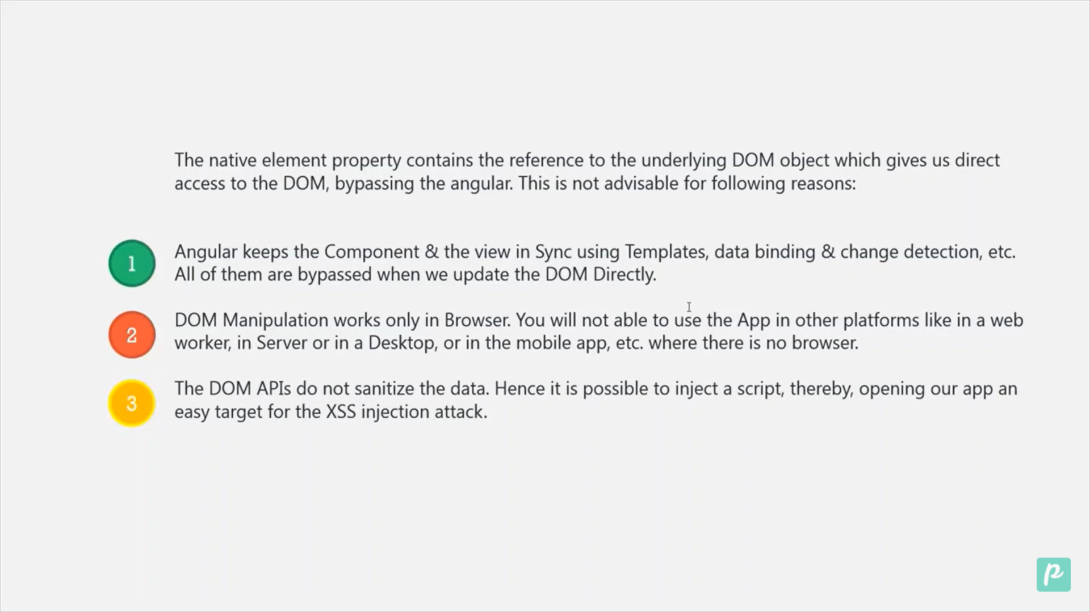

Step 1: we will create a directive highlight.

Ng g d highlight.

When we use directive on html it receive as an argument in constructor.The constructor will receive another parameter rendered and type is rendered2.

Step 2:Now we will

import { Directive, ElementRef, Renderer2, OnInit } from '@angular/core';

@Directive({

  selector: '[appHighlight]',

})

export class HighlightDirective implements OnInit {

  constructor(private element: ElementRef, private rendered: Renderer2) {}

  ngOnInit() {

    this.rendered.setStyle(

      this.element.nativeElement,

      'backgroundColor',

      'Green'

    );

  }

}

